COMMON COURSE ASSIGNMENT REPORT
DEEP LEARNING-BASED DEEPFAKE DETECTION
FOR SOCIAL MEDIA CONTENT

NAME:S.MYTHILI
REG NUM:192411250

A. ASSIGNMENT INFORMATION
Particular | Details
Department | Computer Science And Engineering
Programme | B.Tech –CSE
Course Code & Course Name | CSA1711-AI
Academic Year / Batch | 2024-2028
Faculty Name | Dr.Krishnakumar K
Assignment Title | Deep Learning-Based Deepfake Detection for Social Media Content
Date of Issue | 3/09/2026
Date of Submission | 3/09/2026
Maximum Marks | 100
Course Outcome(s) – CO | To be mapped by faculty according to the course
Bloom's Taxonomy Level | L3 – Apply, L4 – Analyze, L5 – Evaluate, L6 – Create
SDG Mapping (SDG 1–17) | SDG 9 – Industry, Innovation and Infrastructure; SDG 16 – Peace, Justice and Strong Institutions
Industry / Societal Relevance | Synthetic-media screening, digital forensics, content moderation, misinformation reduction and trustworthy media systems

B. ASSIGNMENT PROBLEM / CHALLENGE
Social-media platforms enable images and videos to reach large audiences within seconds. At the same time, face-manipulation technologies can produce realistic synthetic media that is difficult to identify by visual inspection alone. The assignment therefore requires the design and implementation of a practical deep learning system that can screen facial media and classify it as Real or Deepfake.
The task is intentionally application-oriented. Instead of reproducing only theoretical definitions, the student must formulate the problem, identify constraints, select algorithms, construct a processing pipeline, implement the solution with modern computing tools, evaluate the model, interpret the results and justify the final design.

B.1 Required Student Activities
- Apply deep learning and computer-vision concepts to a real-world media-authenticity problem.
- Analyse input, dataset, computational and reliability requirements.
- Develop a complete face-focused classification pipeline.
- Use modern tools such as Python, TensorFlow/Keras, MTCNN and OpenCV.
- Validate the solution using quantitative metrics and representative execution outputs.
- Discuss limitations, ethical considerations and responsible use.
This directly reflects the uploaded assignment format, which asks students to apply course concepts, identify and analyse the problem, consider requirements and constraints, develop solutions and use relevant modern tools.

C. PROBLEM STATEMENT
Design and implement a deep learning-based system for detecting potentially manipulated facial content in social-media images and videos. The system shall accept a supported image or video, locate usable facial regions, preprocess the detected face, classify the facial content using a deep learning model, and produce a final Real/Deepfake decision. For video input, the system shall analyse representative frames and combine frame-level decisions into a single video-level prediction.
The revised implementation uses Multi-task Cascaded Convolutional Networks (MTCNN) for face detection, XceptionNet transfer learning for visual classification, and temporal majority voting for video-level decision making. This replaces the previous EfficientNet-B0 classification backbone and probability-averaging approach.

C.1 Expected Outcomes
- A working deepfake detection pipeline.
- A clearly documented architecture and flowchart.
- A trained or fine-tuned XceptionNet binary classifier.
- Frame-level and video-level prediction logic.
- Testing evidence and quantitative evaluation.
- A justified engineering decision explaining why the revised algorithms were selected.

C.2 Key Assumptions
- The dataset contains reliable Real and Deepfake labels.
- Facial manipulation is sufficiently visible in at least some analysed frames.
- A source-aware split is used to reduce train/test leakage.
- The system is used as a screening aid rather than a legal or forensic proof mechanism.

D. REQUIREMENTS AND CONSTRAINTS
The assignment format requires relevant functional, performance, technical, resource, safety, reliability, sustainability, ethical and security considerations to be identified where applicable. fileciteturn2file0L36-L53

D.1 Functional Requirements
ID | Requirement | Description
FR1 | Input handling | Accept supported image and video files.
FR2 | Frame sampling | Extract representative frames from videos.
FR3 | Face detection | Detect facial regions using MTCNN.
FR4 | Preprocessing | Crop, resize and normalise facial images.
FR5 | Classification | Predict Deepfake probability using XceptionNet.
FR6 | Video decision | Use majority voting across usable frame labels.
FR7 | Output | Display final class and confidence information.
FR8 | Error handling | Report invalid files or insufficient facial evidence.

D.2 Performance Requirements
- The model should provide stable validation performance before final testing.
- The system should avoid unnecessary processing of every video frame.
- The final evaluation should report more than accuracy alone.
- Threshold selection should be performed using validation data rather than the final test set.

D.3 Technical Constraints
- XceptionNet uses a 299 × 299 input representation in the selected configuration.
- MTCNN detection quality affects the quality of the classifier input.
- GPU acceleration is preferred for training but is not mandatory for a small prototype.
- Dataset size, storage and training time constrain experimentation.

D.4 Security, Privacy and Ethics
- Uploaded media should be handled according to applicable privacy requirements.
- Predictions should not be presented as absolute proof of deception.
- High-impact decisions should include human review.
- Datasets must be used according to their licence and intended research conditions.

E. STUDENT WORK

1. Problem Understanding and Formulation
The problem is formulated as binary classification of facial media. Each usable face crop is represented as an input sample and associated with a Real or Deepfake label during supervised learning. For video, several frames are treated as evidence for one final media-level decision.
The main challenge is that the visual evidence is affected by identity, lighting, pose, camera quality, compression and manipulation method. The proposed pipeline therefore separates the task into face localisation, feature learning and decision aggregation.

1.1 Information/Data Available
- Labelled Real and Deepfake image/video examples.
- Video frames obtained through OpenCV sampling.
- Face bounding boxes and confidence values from MTCNN.
- XceptionNet probability outputs for detected face crops.
- Ground-truth labels for evaluation.

1.2 Problem Formulation
For a face crop x, XceptionNet estimates p = P(Deepfake | x). A validation-selected threshold T converts the probability into a frame label: Deepfake if p ≥ T; otherwise Real. For n usable video frames, the final label is the class with the larger number of frame votes.
DeepfakeVotes = Σ I(pi ≥ T)
RealVotes = n − DeepfakeVotes
Final = Deepfake if DeepfakeVotes > RealVotes; otherwise Real

2. APPLICATION OF COURSE KNOWLEDGE
The implementation applies concepts from deep learning, computer vision, supervised classification, transfer learning, preprocessing, model evaluation and experimental validation. The revised algorithm selection is based on the need for a face-focused, transferable visual classifier and a transparent video decision mechanism.

2.1 Deep Learning Concepts Applied
- Convolutional feature extraction
- Transfer learning
- Binary classification
- Sigmoid output
- Binary cross-entropy loss
- Adam optimisation
- Dropout regularisation
- Validation-based model selection

2.2 Evaluation Metrics
Accuracy measures the proportion of correct predictions. Precision measures how many predicted Deepfake samples are actually Deepfake. Recall measures how many actual Deepfake samples are detected. F1-score balances precision and recall.
Accuracy = (TP + TN) / (TP + TN + FP + FN)
Precision = TP / (TP + FP)
Recall = TP / (TP + FN)
F1 = 2 × Precision × Recall / (Precision + Recall)

2.3 Confusion Matrix Interpretation
Actual / Predicted | Real | Deepfake
Real | TN | FP
Deepfake | FN | TP

3. SOLUTION / DESIGN / METHODOLOGY
The proposed design contains six main processing stages: input acquisition, frame sampling, MTCNN face detection, facial preprocessing, XceptionNet classification and temporal majority voting. The design is modular so that each stage can be independently tested and later upgraded.
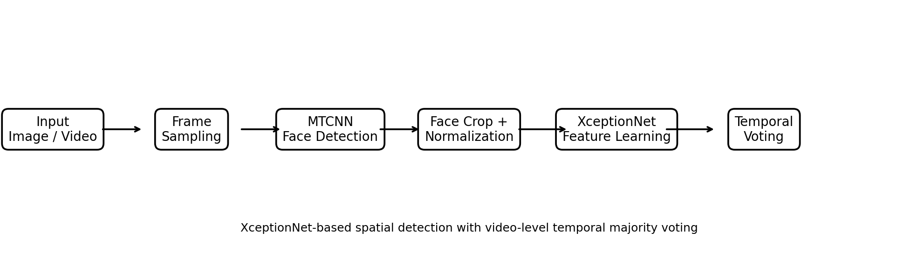
Figure 1: Proposed MTCNN + XceptionNet + Temporal Majority Voting architecture

3.1 Revised Algorithmic Design
Stage | Earlier Approach | Revised Approach | Reason for Revision
Face/Input Preparation | General image preprocessing | MTCNN face detection | Focus the classifier on facial evidence
CNN Backbone | EfficientNet-B0 | XceptionNet | Use a different transfer-learning architecture
Video Aggregation | Probability averaging | Temporal majority voting | Create a transparent frame-decision rule
Output | Class + averaged score | Class + vote confidence | Match the new decision mechanism

The uploaded assignment format expects students to develop a solution/design/methodology and consider more than one possible solution where appropriate.

3.2 Architecture Details

MTCNN Face Detection
MTCNN is positioned before the classifier. It identifies candidate faces and supplies bounding coordinates and confidence values. The selected facial region is cropped and passed to the next stage.

XceptionNet Transfer Learning
The XceptionNet convolutional backbone is used without its original top classification layer. A global average pooling layer and lightweight dense classification head are added. The output layer uses sigmoid activation to produce a value between 0 and 1 representing the estimated Deepfake probability.
from tensorflow.keras.applications import Xception
from tensorflow.keras import Sequential
from tensorflow.keras.layers import GlobalAveragePooling2D, Dropout, Dense
base = Xception(weights="imagenet",
include_top=False,
input_shape=(299, 299, 3))
base.trainable = False
model = Sequential([
base,
GlobalAveragePooling2D(),
Dropout(0.40),
Dense(128, activation="relu"),
Dropout(0.25),
Dense(1, activation="sigmoid")
])

Temporal Majority Voting
Each usable frame is converted into a Real or Deepfake label after thresholding. The final video label is selected by comparing the number of votes received by the two classes.

3.3 System Flow
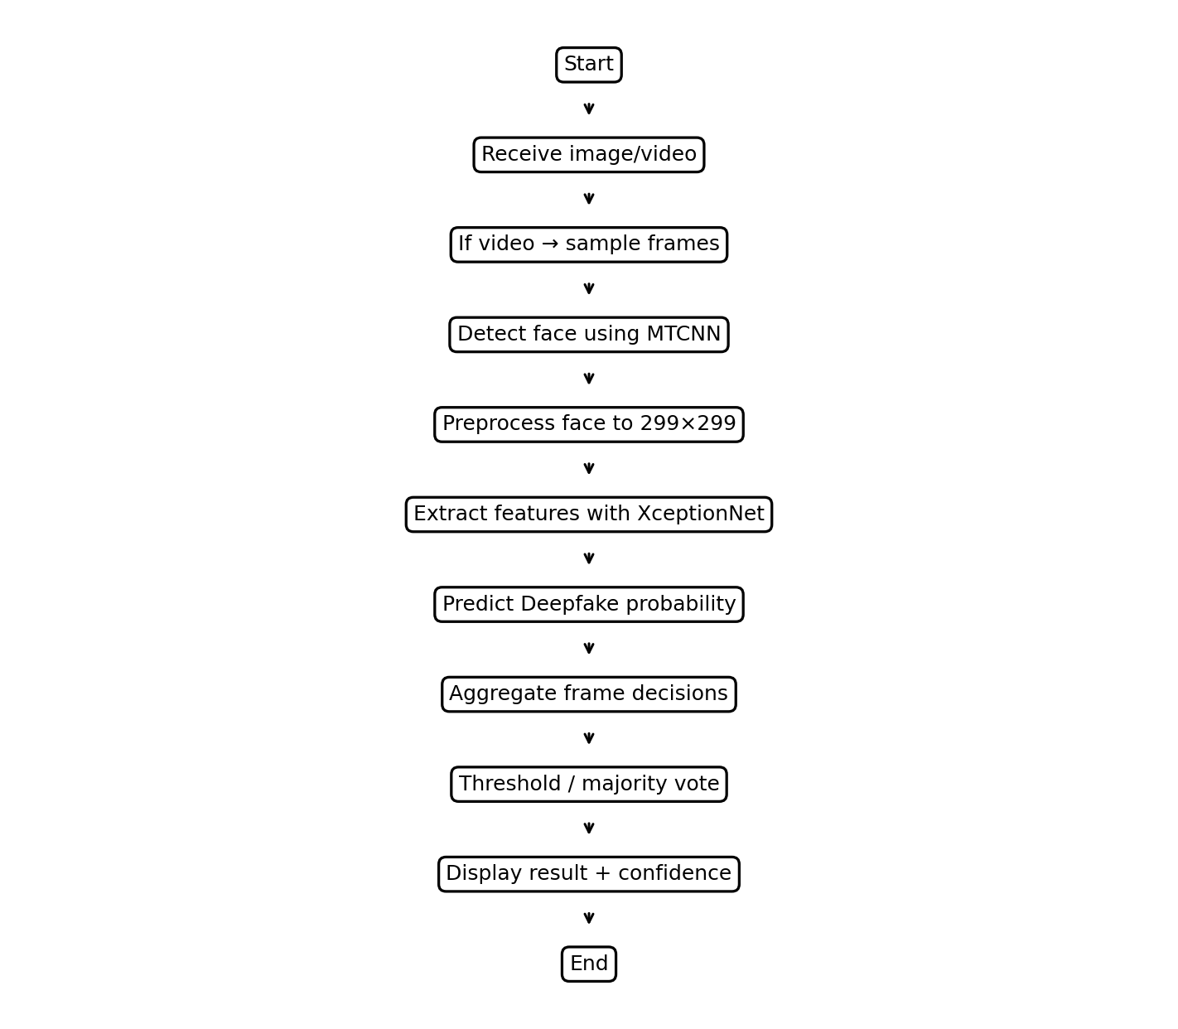
Figure 2: Detailed flowchart of the revised deepfake detection pipeline

3.4 Processing Sequence
- Receive an image or video.
- For video, sample representative frames.
- Run MTCNN on each selected frame.
- Reject or log frames without usable facial evidence.
- Crop and resize the selected face to 299 × 299.
- Apply XceptionNet-compatible preprocessing.
- Generate Deepfake probability.
- Convert each frame probability to a class label.
- Apply majority voting to usable frame labels.
- Display the final class and vote confidence.

4. USE OF MODERN TOOLS
The assignment format explicitly expects evidence of appropriate modern tool usage. fileciteturn2file0L88-L98
Tool | Use in Project | Evidence to Maintain
Python | Main implementation language | Source files / notebook
TensorFlow / Keras | XceptionNet training and inference | Model summary, training log
MTCNN | Face localisation | Detection output
OpenCV | Video reading and frame sampling | Frame extraction output
NumPy | Numerical processing and voting | Inference code
Pandas | Result organisation where required | Evaluation table
Matplotlib | Accuracy curves and confusion matrix | Saved plots
VS Code / Jupyter | Development and experimentation | Screenshots / notebook

4.1 Recommended Environment
Python 3.x
TensorFlow / Keras
OpenCV
MTCNN
NumPy
Pandas
Matplotlib

4.2 Dataset Strategy
A suitable research dataset may contain real and manipulated facial videos or images. Examples commonly used in academic deepfake research include FaceForensics++ and Celeb-DF, subject to their respective access and usage conditions. The final submission should state the exact dataset used, its source, number of samples, and train/validation/test split.

4.3 Source-Aware Splitting
Frames originating from the same source video should not be randomly divided across training and testing. Otherwise, near-duplicate visual content may appear in both sets, causing data leakage and an inflated evaluation score.

5. RESULTS AND VALIDATION
The assignment format requires results to be presented using appropriate tables, graphs, experimental observations, screenshots and performance metrics, followed by validation against stated requirements. fileciteturn2file0L99-L109

5.1 Important Reporting Note
The numerical values in this section are clearly labelled as ILLUSTRATIVE because no verified XceptionNet execution log was supplied with this assignment-format file. They demonstrate how the revised algorithm's results should be documented. Before final academic submission, replace them with measurements from the actual XceptionNet implementation.
Metric | Illustrative Result
Accuracy | 92.0%
Precision | 91.2%
Recall | 93.0%
F1-score | 92.1%
Specificity | 91.0%
ROC-AUC | 0.95

5.2 Illustrative Confusion Matrix
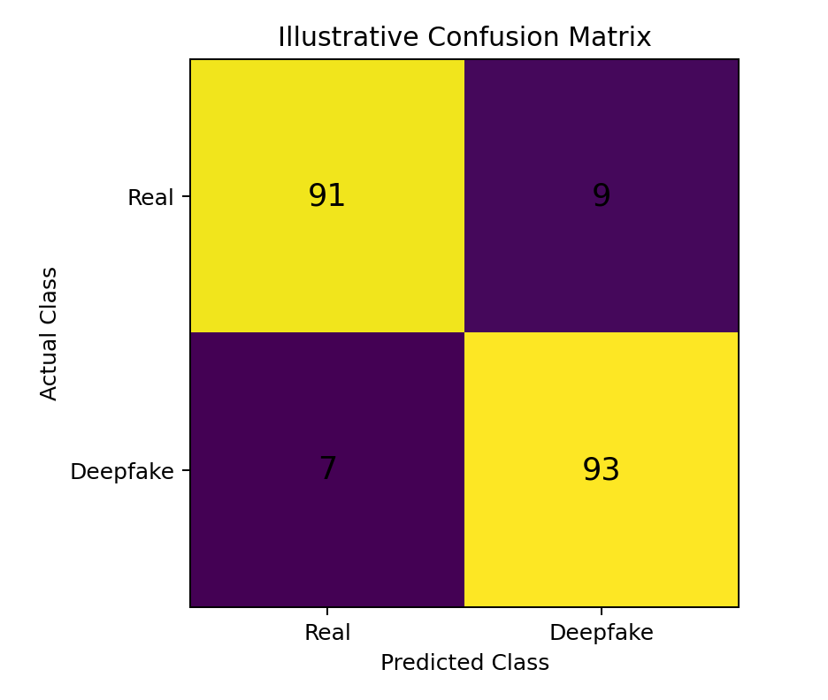
Figure 3: Illustrative confusion matrix; replace with actual test-set counts
The illustrative matrix contains TN = 91, FP = 9, FN = 7 and TP = 93. These counts produce 184 correct predictions out of 200, giving 92% illustrative accuracy. They are examples for formatting and are not actual measured results.
5.3 Illustrative Learning Curve
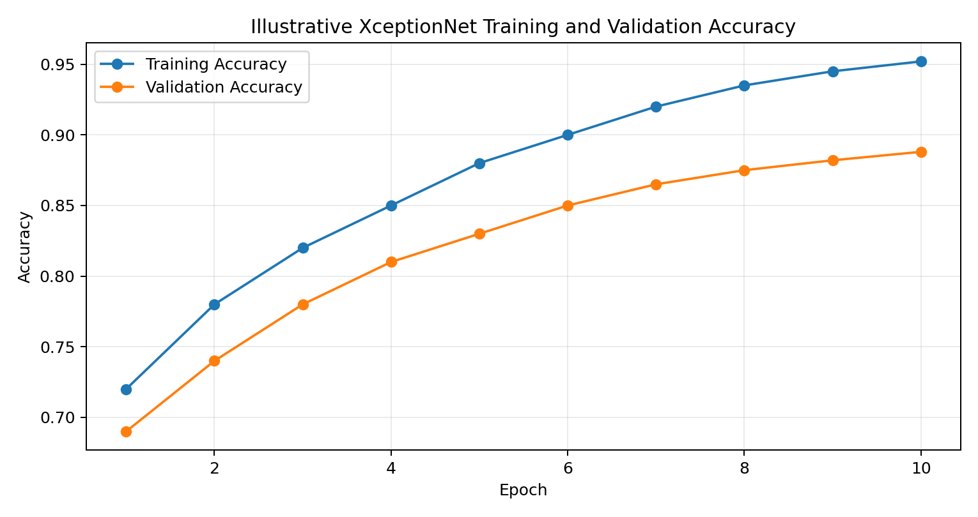
Figure 4: Illustrative XceptionNet training and validation accuracy
A useful learning curve should be generated directly from the final training history. The gap between training and validation performance can help identify overfitting. Early stopping and limited fine-tuning may be used if validation performance stops improving.

5.4 Illustrative Execution Output
DEEPFAKE DETECTION SYSTEM
==========================
Algorithm : MTCNN + XceptionNet
Decision Rule : Temporal Majority Voting
Input : sample_video.mp4
Frames Sampled : 20
Usable Faces : 18
Deepfake Votes : 13
Real Votes : 5
Prediction : DEEPFAKE
Vote Confidence: 72.22%
The output format is aligned with the revised majority-voting algorithm. The final class is Deepfake because 13 of the 18 usable frames receive the Deepfake label. Vote confidence is 13/18 = 72.22%.

5.5 Test Cases
Test ID | Condition | Expected Result | Evidence
TC01 | Known Real image | REAL | Prediction screenshot
TC02 | Known Deepfake image | DEEPFAKE | Prediction screenshot
TC03 | Valid video | Final label from majority voting | Execution output
TC04 | No detectable face | Insufficient facial evidence | Console/log output
TC05 | Unsupported/corrupt file | Safe error message | Error screenshot
TC06 | Low-resolution face | Prediction or low-quality warning | Execution output
TC07 | Multiple faces | Defined face-selection behaviour | Execution output
TC08 | Held-out test set | Metrics and confusion matrix | Evaluation report

5.6 Requirement Validation
Requirement | Validation Method | Acceptance Evidence
Face localisation | Run MTCNN on test frames | Detected face crop
Classification | Run XceptionNet inference | Probability and label
Video decision | Count frame votes | Final majority label
Evaluation | Compute metrics | Metric table
Robustness | Test difficult inputs | Test-case results
Documentation | Record tools and outputs | Screenshots / report

6. ANALYSIS AND ENGINEERING DECISION
The assignment format asks students to interpret results, compare alternatives where appropriate, identify advantages and limitations, discuss trade-offs, and justify the final solution using quantitative or qualitative evidence. fileciteturn2file0L110-L117

6.1 Algorithm Comparison
Option | Strength | Limitation | Decision
EfficientNet-B0 | Compact and efficient | Used in earlier report version | Not selected
XceptionNet | Strong transfer-learning baseline; distinct architecture | Higher input resolution and computation | Selected
Simple image classifier | Easy to implement | Weak face focus | Not selected
Probability averaging | Uses probability magnitude | Sensitive to extreme frame probabilities | Not selected
Majority voting | Simple and transparent | Discards probability magnitude | Selected

6.2 Why XceptionNet Was Selected

- Provides a substantially different CNN backbone from the earlier report.
- Supports transfer learning, reducing the need for very large training resources.
- Depthwise separable convolutions provide a factorised convolutional design.
- The architecture is suitable for image-level facial classification experiments.

6.3 Why Majority Voting Was Selected
- Easy to explain during demonstration.
- Reduces dependence on a single sampled frame.
- Produces a directly interpretable count of frame decisions.
- Requires no additional recurrent or transformer module.

6.4 Trade-Off
The main trade-off is simplicity versus temporal intelligence. Majority voting is computationally light and transparent, but it does not learn motion patterns. A learned temporal model could use more information but would increase implementation complexity and training requirements.
6.5 Error Analysis
- False positives may occur when genuine media contains unusual compression or lighting artifacts.
- False negatives may occur when manipulation traces are weak or unseen during training.
- MTCNN failures reduce the amount of usable evidence.
- Low-resolution faces can reduce the quality of XceptionNet features.
- Dataset bias may cause strong benchmark performance but weak real-world generalisation.

6.6 Engineering Decision
The final solution is selected because it balances implementation complexity, visual feature quality and explainability. MTCNN narrows the input to facial evidence, XceptionNet provides a modern transfer-learning classifier, and majority voting creates a simple video-level decision mechanism. The design is appropriate for an academic prototype and provides clear extension points for future research.

7. BROADER CONSIDERATIONS
The assignment format identifies sustainability, environment, society, safety, ethics, economics, accessibility and professional responsibility as possible broader considerations. fileciteturn2file0L118-L128

7.1 Social Impact
Automated deepfake screening can support content moderation and media verification. However, incorrect predictions can affect a person's reputation or the perceived credibility of genuine content. The system should therefore be used as an assistive screening mechanism.

7.2 Ethical Considerations
- Avoid presenting model predictions as unquestionable facts.
- Protect personal media and avoid unnecessary storage of uploaded files.
- Disclose model limitations and possible false positives/negatives.
- Use datasets and media according to applicable permissions and licences.

7.3 Sustainability
Deep learning training can consume substantial computational resources. Frame sampling reduces redundant video processing, while transfer learning avoids the need to train a large visual backbone from scratch. These choices can reduce unnecessary computation for a student-scale prototype.

7.4 Professional Responsibility
A professional system should log model version, dataset version, threshold, evaluation procedure and known limitations. Reproducibility and transparent reporting are important when automated predictions may influence decisions about digital content.

8. CONCLUSION
The proposed assignment solution develops a complete deep learning pipeline for screening potentially manipulated facial media. The revised architecture uses MTCNN for facial localisation, XceptionNet transfer learning for spatial classification, and temporal majority voting for video-level decisions.
The system satisfies the core design requirements by accepting media, extracting usable facial evidence, producing frame-level predictions and combining them into an interpretable final result. The evaluation strategy includes accuracy, precision, recall, F1-score, confusion matrix and ROC-AUC where probability outputs are available.
The main limitation is that spatial classification and majority voting do not fully model temporal inconsistencies. In addition, performance depends strongly on dataset diversity and face-detection quality. The numerical examples in this report are illustrative and must be replaced with actual execution measurements before submission.

8.1 Major Findings
- A face-focused preprocessing stage is useful for concentrating the classifier on manipulated regions.
- XceptionNet provides a distinct transfer-learning alternative to the earlier EfficientNet-B0 design.
- Majority voting provides a simple and explainable video-level decision.
- Robust evaluation requires source-aware splitting and multiple metrics.
- Human verification remains important for high-impact use cases.

9. STUDENT REFLECTION
This assignment provided practical learning beyond simply studying deep learning architectures. The major learning outcome was understanding how a machine-learning model becomes part of a complete engineering pipeline. A classifier alone is not sufficient; the quality of face detection, preprocessing, dataset organisation, threshold selection, testing and result interpretation also affects the final system.
I learned that changing an algorithm changes more than the model name. The preprocessing dimensions, model construction, training configuration, output interpretation and evaluation narrative must all remain consistent with the selected architecture. Moving to XceptionNet required the report to be redesigned around a 299 × 299 input and a transfer-learning classification head.
I also learned the importance of distinguishing illustrative results from measured results. A technically correct report should never present an assumed accuracy as if it were obtained from an actual experiment. If additional time and resources were available, I would perform cross-dataset evaluation, tune the threshold using a dedicated validation set, add temporal feature learning, and use Grad-CAM to inspect which facial regions influence the model.

9.1 Improvements With Additional Resources
- Train with a larger and more diverse dataset.
- Add LSTM/GRU or transformer-based temporal modelling.
- Perform cross-dataset generalisation testing.
- Use stronger augmentation and compression simulation.
- Add Grad-CAM or similar explanations.
- Calibrate confidence scores and evaluate different thresholds.

10. REFERENCES
1. Chollet, F. (2017). Xception: Deep Learning with Depthwise Separable Convolutions. IEEE Conference on Computer Vision and Pattern Recognition.
2. Zhang, K., Zhang, Z., Li, Z., and Qiao, Y. (2016). Joint Face Detection and Alignment Using Multi-task Cascaded Convolutional Networks. IEEE Signal Processing Letters.
3. Rössler, A., Cozzolino, D., Verdoliva, L., Riess, C., Thies, J., and Nießner, M. (2019). FaceForensics++: Learning to Detect Manipulated Facial Images. IEEE/CVF International Conference on Computer Vision.
4. Li, Y., Yang, X., Sun, P., Qi, H., and Lyu, S. (2020). Celeb-DF: A Large-Scale Challenging Dataset for DeepFake Forensics. IEEE/CVF Conference on Computer Vision and Pattern Recognition.
5. Goodfellow, I., Bengio, Y., and Courville, A. (2016). Deep Learning. MIT Press.
6. Kingma, D. P., and Ba, J. (2015). Adam: A Method for Stochastic Optimization. International Conference on Learning Representations.
7. Selvaraju, R. R., et al. (2017). Grad-CAM: Visual Explanations from Deep Networks via Gradient-Based Localization. IEEE International Conference on Computer Vision.
8. TensorFlow / Keras documentation for Xception, model training and inference.
9. OpenCV documentation for video processing and frame extraction.
10. MTCNN implementation/documentation used for face detection.
The uploaded assignment format explicitly requires acknowledgement of external sources, datasets, standards, software and AI-assisted tools used. fileciteturn2file0L136-L142

F. COMMON ASSESSMENT RUBRIC
The following rubric is reproduced in structure from the uploaded Common Course Assignment Format and aligned with this deepfake-detection assignment. fileciteturn2file0L143-L153
Assessment Criterion | Marks
Problem understanding & formulation | 10
Application of course/domain knowledge | 20
Solution methodology / design / implementation | 20
Use of appropriate modern tools / techniques | 10
Results, testing & validation | 15
Analysis, trade-offs & justification | 15
Broader considerations / professional responsibility, where applicable | 5
Technical documentation & reflection | 5
TOTAL | 100

F.1 Rubric Evidence for This Assignment
Criterion | Evidence in Report
Problem understanding | Sections C and E1
Application of knowledge | E2 – algorithms, formulas and deep learning concepts
Solution / implementation | E3 – architecture, code and methodology
Modern tools | E4 – Python, TensorFlow/Keras, MTCNN, OpenCV
Results / validation | E5 – metrics, test cases, confusion matrix and outputs
Analysis / justification | E6 – comparison, trade-offs and decision
Broader considerations | E7 – ethics, privacy, sustainability and responsibility
Documentation / reflection | E8, E9 and references

G. CO–PO–ASSESSMENT MAPPING
The uploaded format states that faculty should map only the COs, POs and Bloom's levels genuinely assessed by the assignment. fileciteturn2file0L156-L167
Assessment Component | CO | PO(s) | Bloom's Level | Marks
Problem formulation | To be filled | To be filled | L3/L4 | 10
Application of knowledge | To be filled | To be filled | L3/L4 | 20
Solution / Design / Implementation | To be filled | To be filled | L4/L5/L6 | 20
Modern tool usage | To be filled | To be filled | L3/L4 | 10
Validation | To be filled | To be filled | L4/L5 | 15
Analysis & justification | To be filled | To be filled | L4/L5 | 15
Broader considerations | To be filled | To be filled | L4/L5 | 5
Documentation & reflection | To be filled | To be filled | L3/L4 | 5

G.1 Suggested Bloom's Alignment
Activity | Suggested Level | Reason
Apply deep learning algorithms | L3 – Apply | Uses learned concepts in a practical system
Analyse dataset and errors | L4 – Analyze | Breaks the problem into evidence and error sources
Compare algorithms | L5 – Evaluate | Judges alternatives using technical criteria
Create final pipeline | L6 – Create | Constructs an integrated working solution

H. FACULTY EVALUATION & CONTINUOUS IMPROVEMENT

H.1 CO Attainment
Performance Level | Criterion
Level 3 | ≥ 70%
Level 2 | 60–69%
Level 1 | 50–59%
Level 0 | < 50%

Target CO Attainment: ____________________
Actual CO Attainment: ____________________

H.2 Faculty Analysis
Areas in which students performed well: __________________________________________________________
Areas requiring improvement: _________________________________________________________________
Corrective / Improvement Action: ______________________________________________________________
Action to be implemented in the next offering: _________________________________________________

H.3 Documents to be Maintained
- Assignment question/problem statement
- CO–PO and Bloom's mapping
- Assessment rubric
- Student submissions
- Tool/simulation/experimental evidence
- Evaluated scripts/reports
- Marks and rubric-wise assessment
- CO attainment analysis
- Sample student work representing different performance levels
- Faculty analysis and continuous-improvement action
These maintenance items follow the uploaded assignment format. fileciteturn2file0L168-L195

APPENDIX A – DETAILED ALGORITHMS

A.1 MTCNN Face Detection Algorithm
INPUT: video/image frame
OUTPUT: usable face crop
1. Read the frame.
2. Run MTCNN face detection.
3. Obtain bounding boxes and confidence values.
4. Remove detections below the configured confidence threshold.
5. Select the required face region.
6. Crop the region with optional margin.
7. Return the crop.

A.2 XceptionNet Inference Algorithm
INPUT: preprocessed face crop
OUTPUT: Deepfake probability
1. Resize image to 299×299.
2. Apply model-compatible preprocessing.
3. Pass image through pretrained XceptionNet.
4. Apply global average pooling.
5. Apply classification head.
6. Generate sigmoid probability p.
7. Return p.

A.3 Temporal Majority Voting Algorithm
INPUT: p1, p2, ..., pn
OUTPUT: video class
1. Set threshold T using validation data.
2. For every usable frame, calculate pi.
3. If pi >= T, assign Deepfake vote.
4. Otherwise assign Real vote.
5. Count both classes.
6. Return the class with more votes.
7. Report vote confidence.

APPENDIX B – IMPLEMENTATION CHECKLIST
Stage | Verification | Final Evidence
Input | Image/video loads successfully | Screenshot
Frame sampling | Correct number of frames sampled | Console output
MTCNN | Faces detected | Face crop image
Preprocessing | 299×299 tensor produced | Code/log
XceptionNet | Model loads and predicts | Model summary/output
Training | History saved | Accuracy/loss graph
Testing | Held-out samples evaluated | Metrics
Voting | Frame labels aggregated | Console output
Final result | Real/Deepfake displayed | Execution screenshot
Documentation | All rubric areas covered | Final report

APPENDIX C – FINAL OUTPUT TEMPLATE
DEEPFAKE DETECTION SYSTEM
Model : XceptionNet Transfer Learning
Face Detector : MTCNN
Video Decision : Temporal Majority Voting
Threshold : [ACTUAL VALUE]
Input : [ACTUAL FILE]
Frames Sampled : [ACTUAL VALUE]
Usable Face Frames : [ACTUAL VALUE]
Deepfake Votes : [ACTUAL VALUE]
Real Votes : [ACTUAL VALUE]
Final Prediction : [REAL / DEEPFAKE]
Vote Confidence : [ACTUAL VALUE]
Replace every bracketed field with values generated by the actual final execution. Do not use the illustrative values from Section E5 as measured results.

APPENDIX D – EXECUTIVE SUMMARY
This assignment develops a deep learning-based deepfake detection system for social-media content. The revised implementation is intentionally different from the previous report: MTCNN replaces generic face preprocessing, XceptionNet replaces EfficientNet-B0 as the principal CNN backbone, and temporal majority voting replaces probability averaging for video-level decisions.
The system first samples video frames, detects faces, crops and normalises the facial regions, and classifies them using a transfer-learned XceptionNet. Frame predictions are then aggregated into a single video-level result. The design emphasises modularity, explainability and practical implementation with Python, TensorFlow/Keras, MTCNN and OpenCV.
The assignment follows the supplied Common Course Assignment Format by covering problem formulation, course-knowledge application, solution design, modern tools, results and validation, analysis and engineering decisions, broader considerations, conclusion, reflection, references, rubric and CO–PO mapping. The supplied format is a seven-page institutional template; this report converts its headings and assessment expectations into a student-submission-ready technical report. fileciteturn2file0L54-L72
Final experimental values should be taken from the student's actual XceptionNet execution. The report intentionally marks example accuracy, confusion-matrix counts and sample output as illustrative so that fabricated measurements are not represented as real experimental evidence.

